**Project Submissions**

**Github repo URL:**

<https://github.com/SSivaneswaran/reactjs-demo.git>

**APP deployed site URL:**

<http://52.200.121.28:80> or http:// <http://52.200.121.28/>

Docker Image names:

I: Capsbuild

II: linux

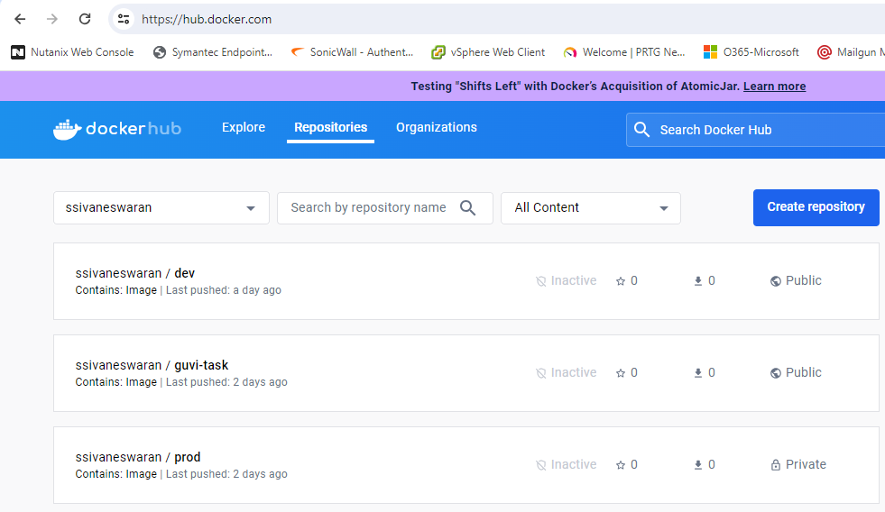

**Jenkins Login Page:**

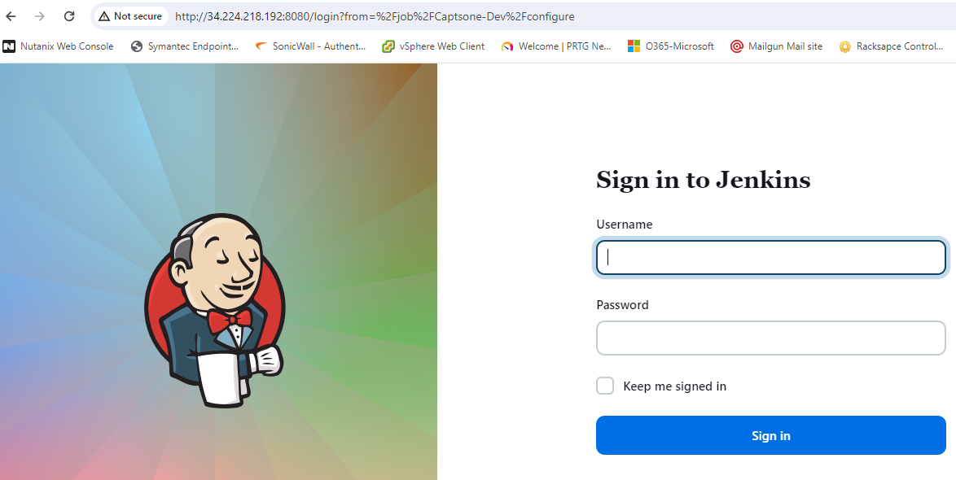

**Deployed Site Page:**

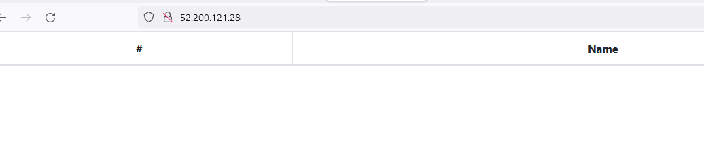

**Monitoring Tool: Prometheus, Node_Exporter and Grafana (UI)**

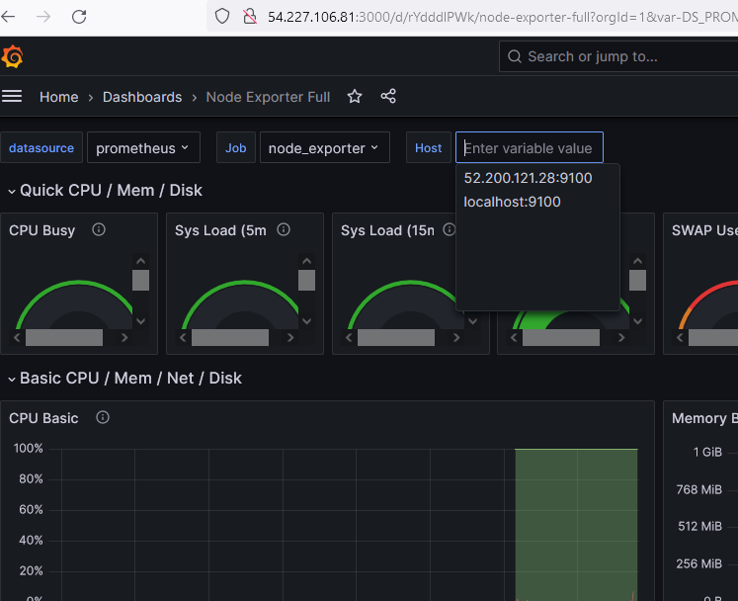

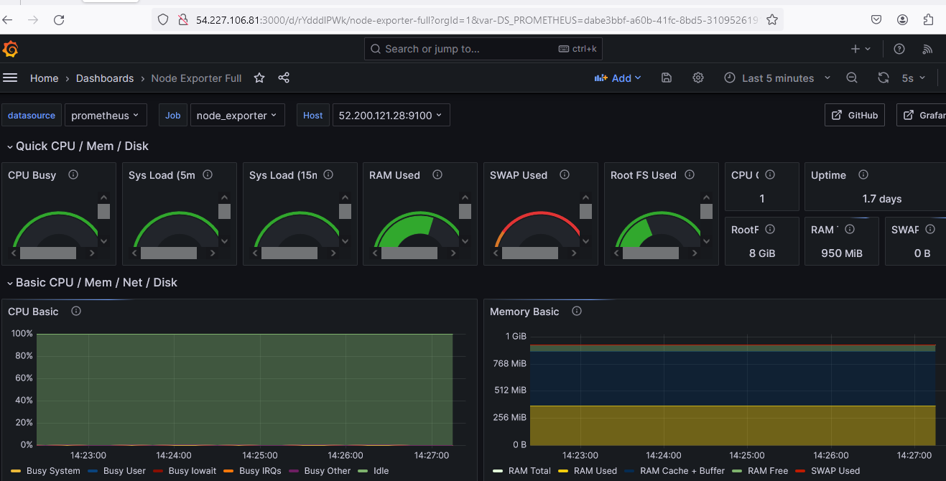

**Steps followed to implement the project:**

Tested in deployment server

App Deployed in live server

Jenkins installed and configured

Monitoring tool installed and configured

**Installations and Configurations screenshots are as follows**

**Tested the application in the development Server**

Cloned the project to my local from git repo

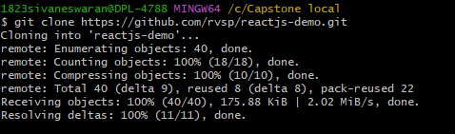



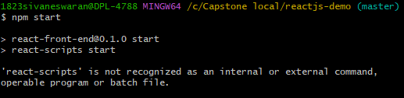

To fix this error, installed the react-scripts and saved

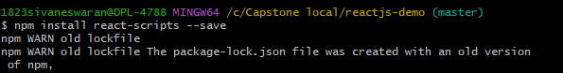

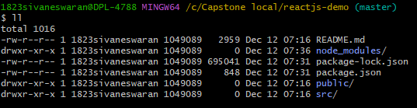

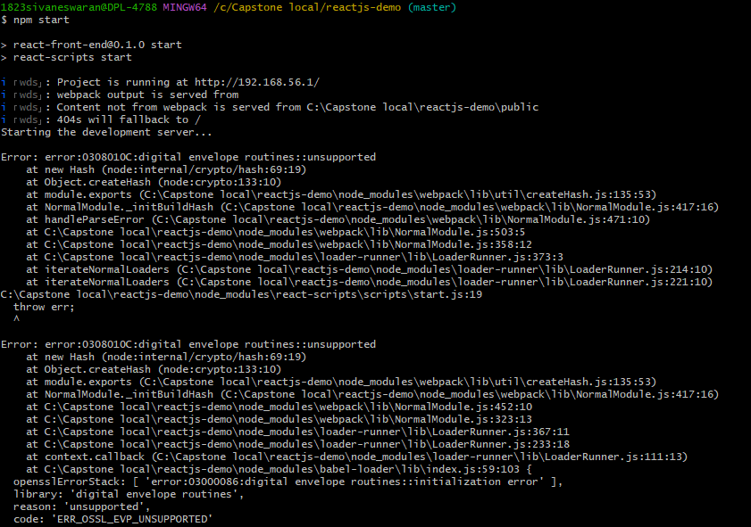

To fix this error I applied the below command to enable the legacy openssl provider



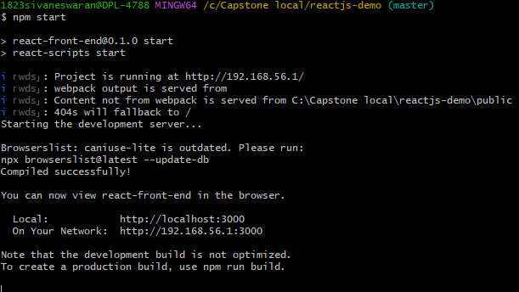

Output of the JS APP

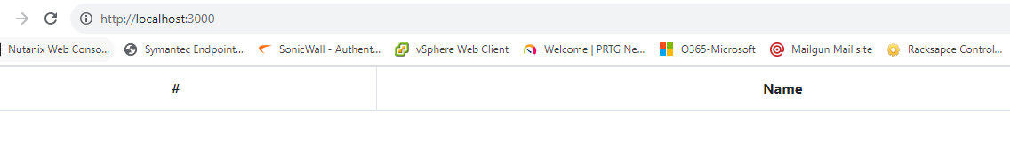

**Created three EC2 instances in AWS-US Virginia Region**

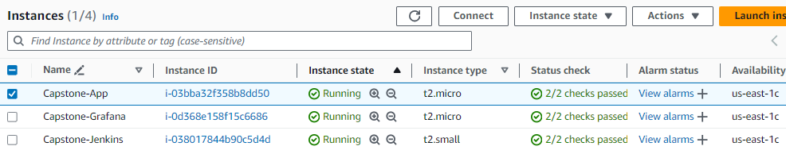

Purpose of the servers:

1: Capstone-Grafana🡺 To monitoring purpose

Running services - Prometheus, Node_Exporter and Grafana

Opened ports - 22, 9090, 9100, 3000 and 80 (22 Allowed only for IP and 8080 opened to all)

2: Capstone-Jenkins🡺 for Continuous Integration and deployment

Running services – Jenkins, Java

Opened ports - 22 and 8080 (22 Allowed only for IP and 8080 opened to all)

3: Capstone-App🡺 for Continuous Integration and deployment

Running services – NodeJS

Opened ports - 22 and 8080 (22 Allowed only for IP and 8080 opened to all)

EC2 Security groups:

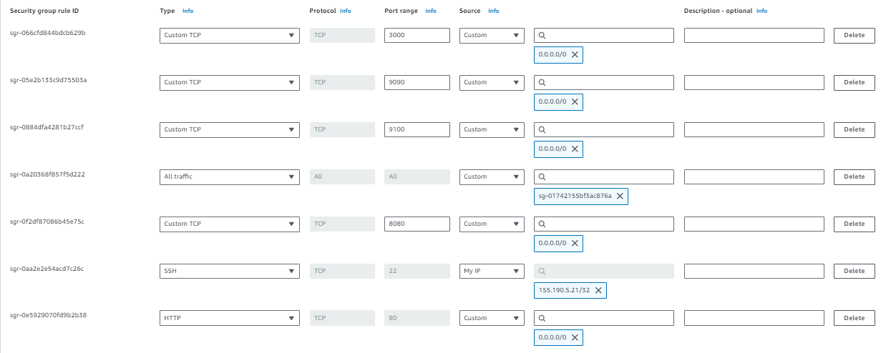

**App Server Installations and Configuration Steps**

Update the apt

Command : apt update

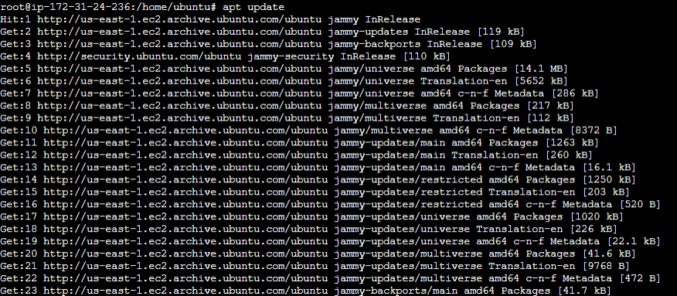

Forked and cloned the git repository

Command: git clone <path>

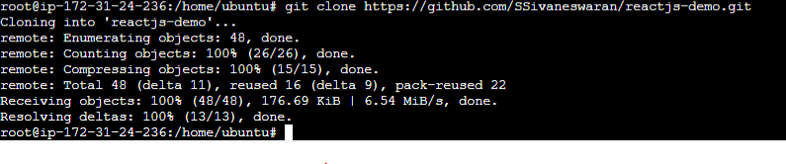

Changed into app directory



Created .dockerignore file

Command: Vi .dockerignore

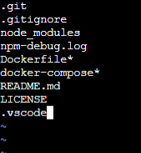

Dockerize the application by creating a Dockerfile

Command: vi Dockerfile

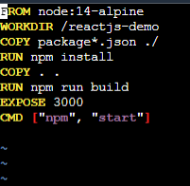

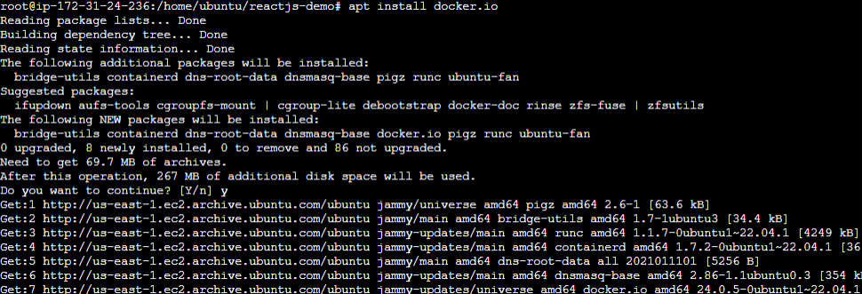

Created shell script to run

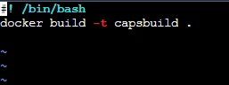



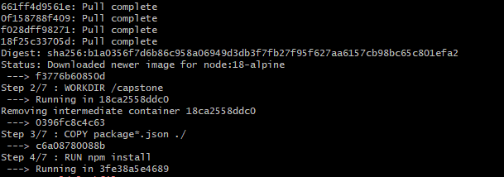



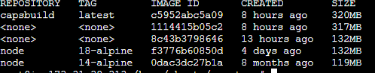

Installing the Docker-compose app

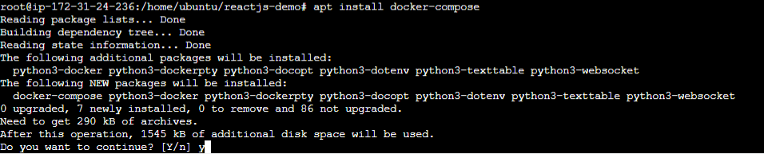

Create a docker-compose file to use the above image

Vi docker-compose.yml

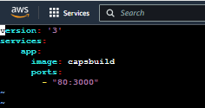

Command: vi deploy.sh

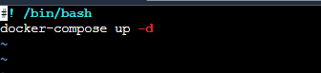

Command: bash deploy.sh



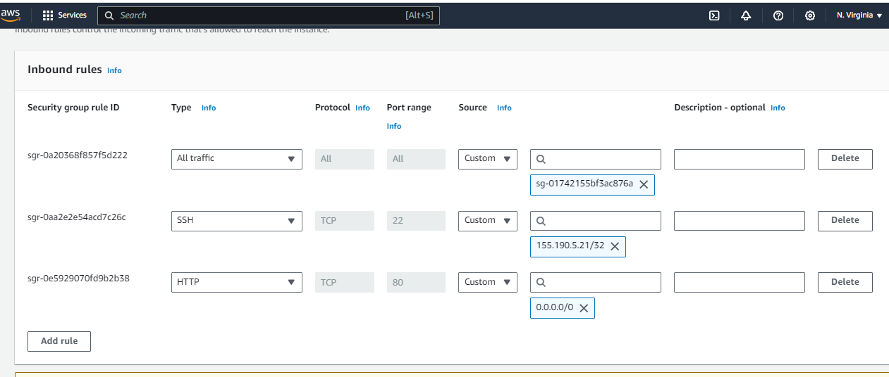

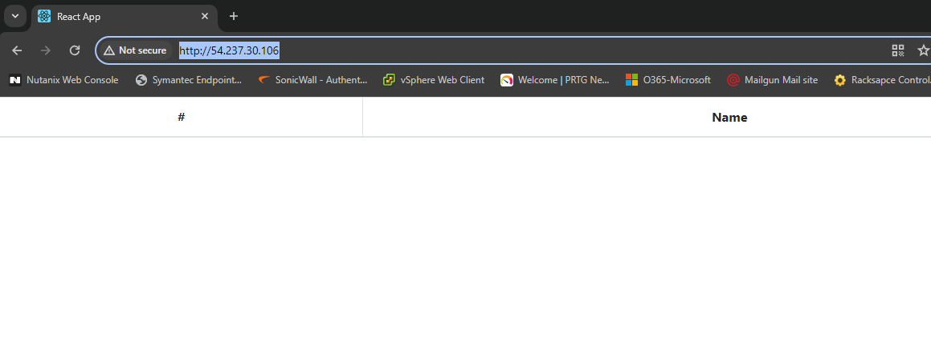

Push the code to github to dev branch (use dockerignore & gitignore files)







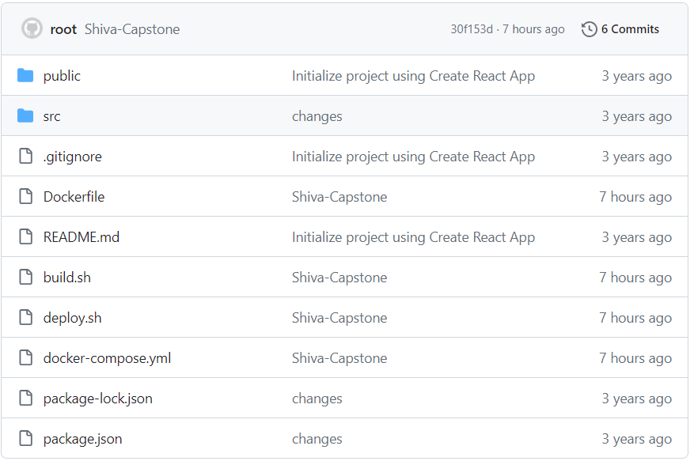

**Jenkins (CI\CD)**

Commands applied to install the Jenkins and Java app in EC2

sudo wget -O /usr/share/keyrings/jenkins-keyring.asc \

https://pkg.jenkins.io/debian-stable/jenkins.io-2023.key

echo deb [signed-by=/usr/share/keyrings/jenkins-keyring.asc] \

https://pkg.jenkins.io/debian-stable binary/ | sudo tee \

/etc/apt/sources.list.d/jenkins.list > /dev/null

sudo apt-get update

sudo apt-get install Jenkins

sudo apt install java

sudo systemctl enable Jenkins

sudo systemctl start Jenkins

sudo systemctl status Jenkins

sudo cat /var/lib/Jenkins/initialAdminPassword

sudo chmod 777 /var/run/docker.sock

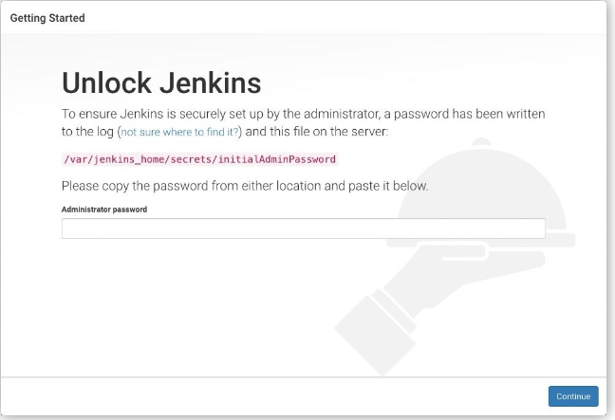

Jenkins portal Login Page



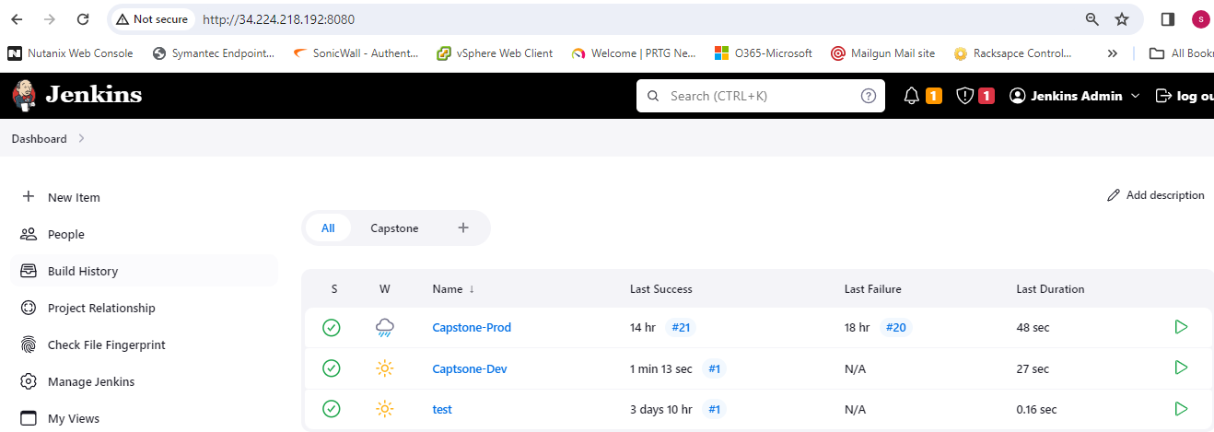

**Jenkins Configurations:**

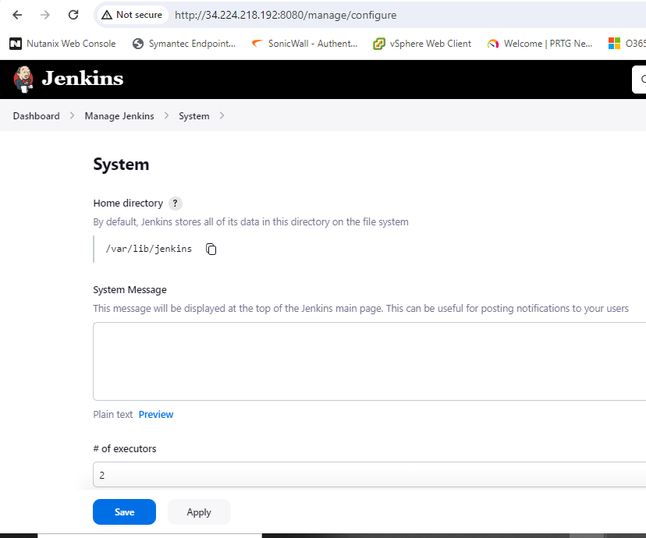

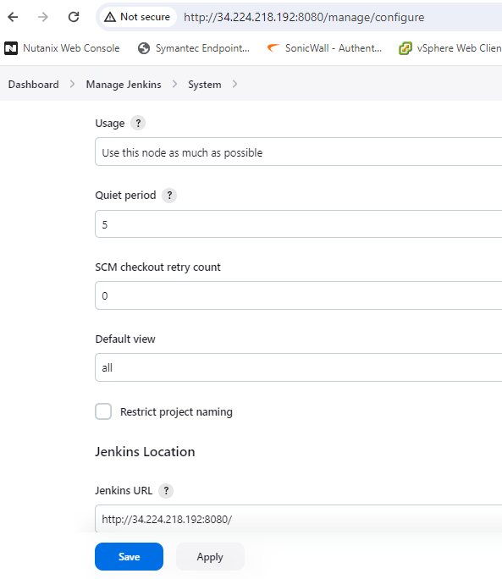

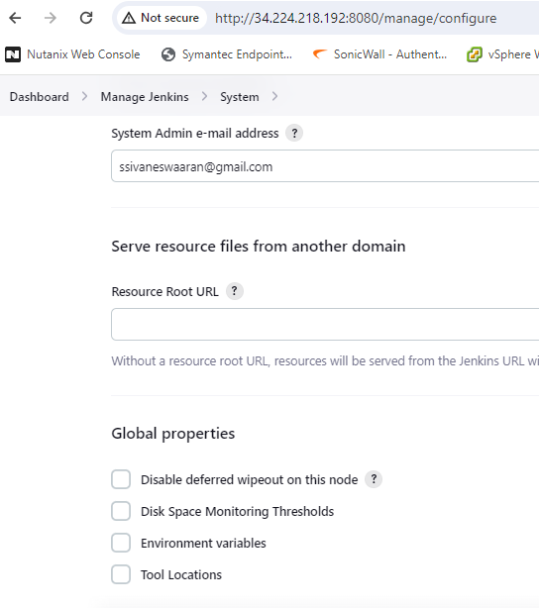

**Created two freestyle projects (Prod and Dev)**

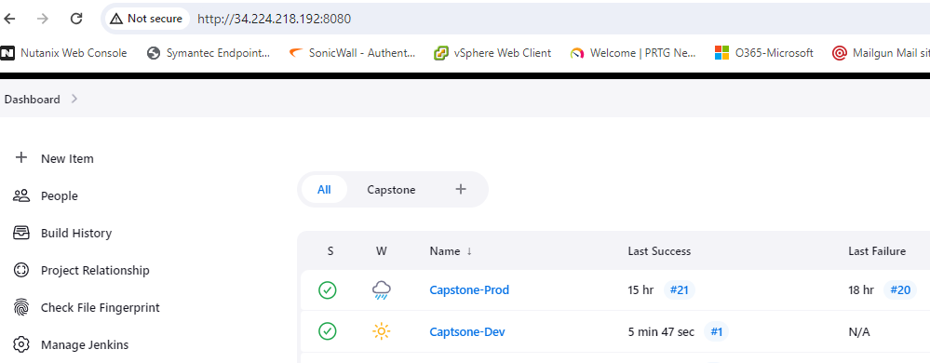

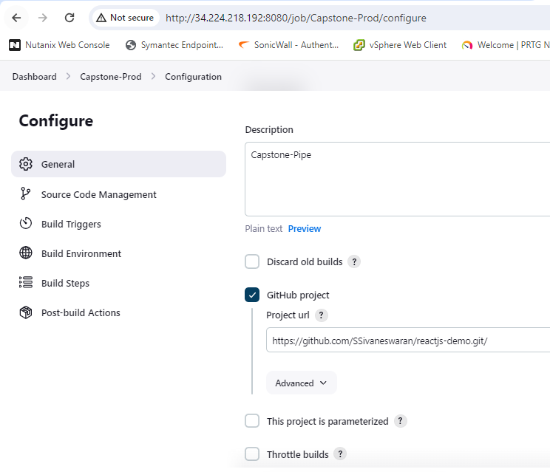

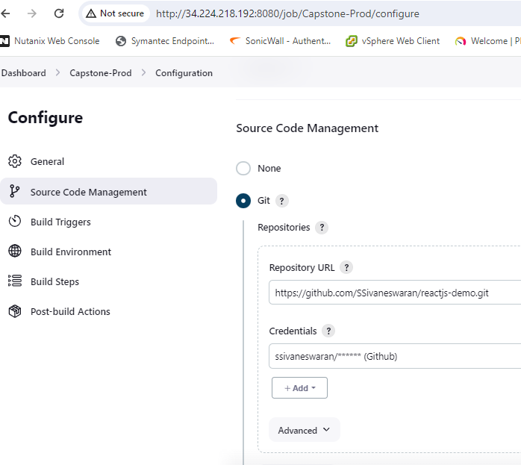

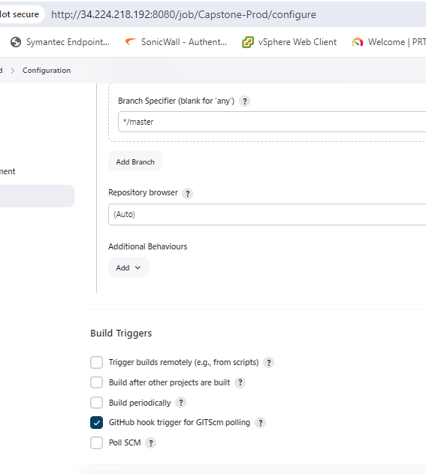

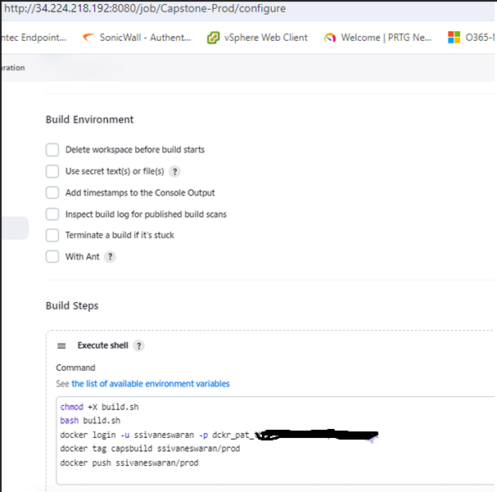

Click save and build now option

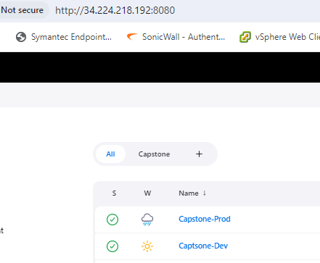

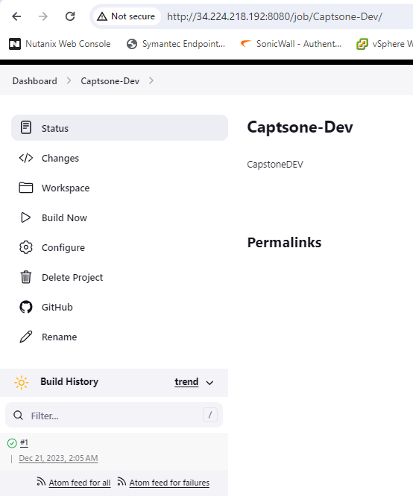

Pushed the images to DockerHub

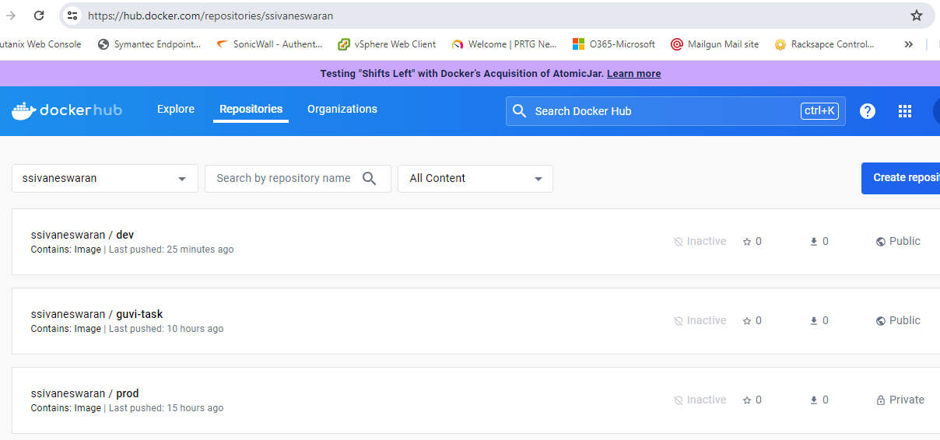

**Monitoring Tool**

**Prometheus(DB collector), Node_Exporter(metrics) and Grafana (UI)**

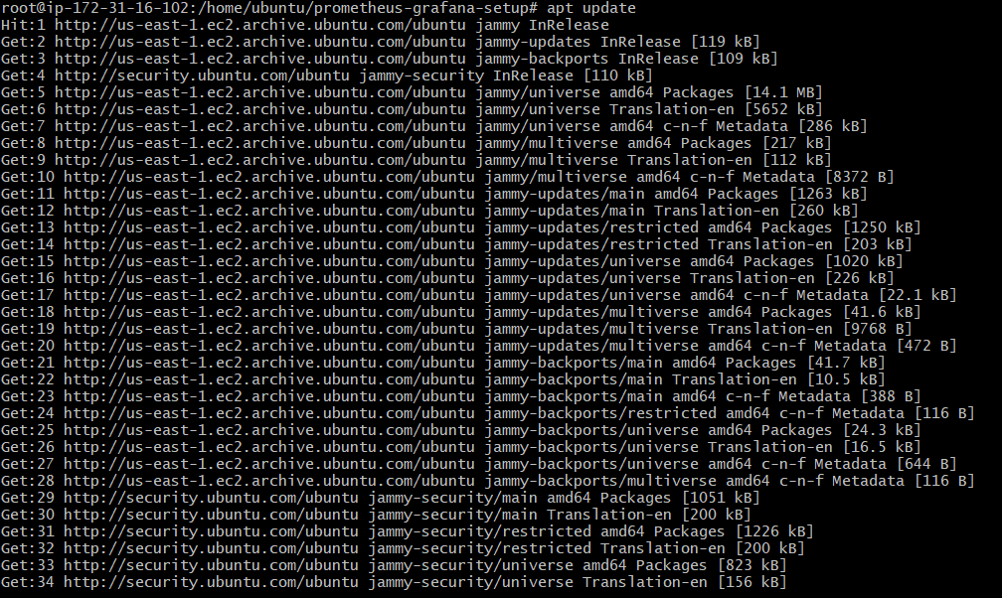

Cloned the source from Github

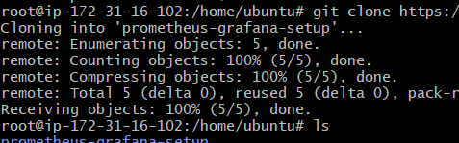

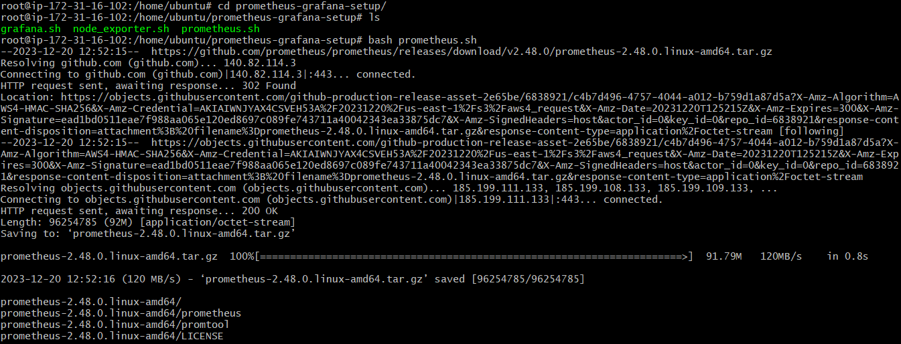

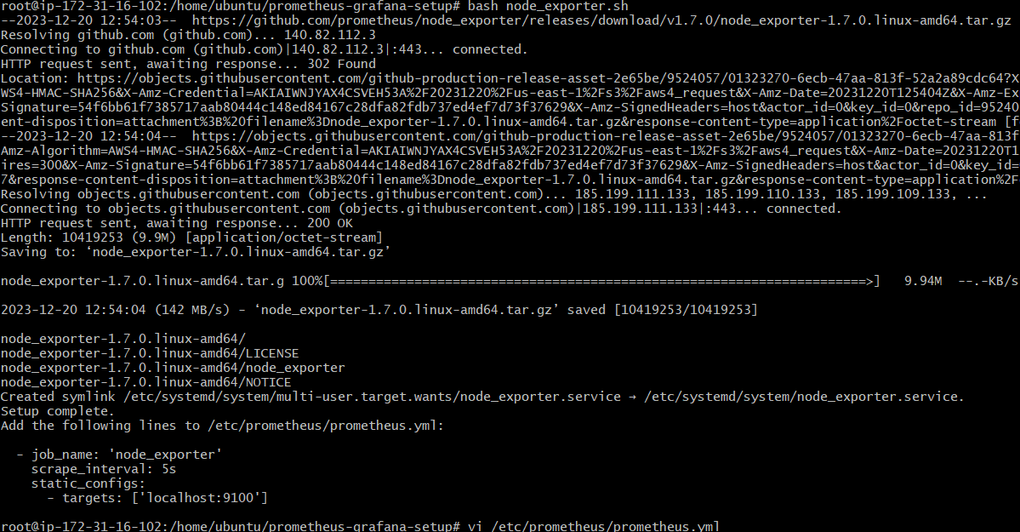



Edited the Prometheus.yml and updated the below inputs to integrate the node exporter

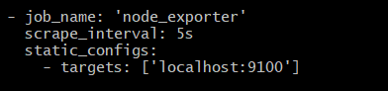

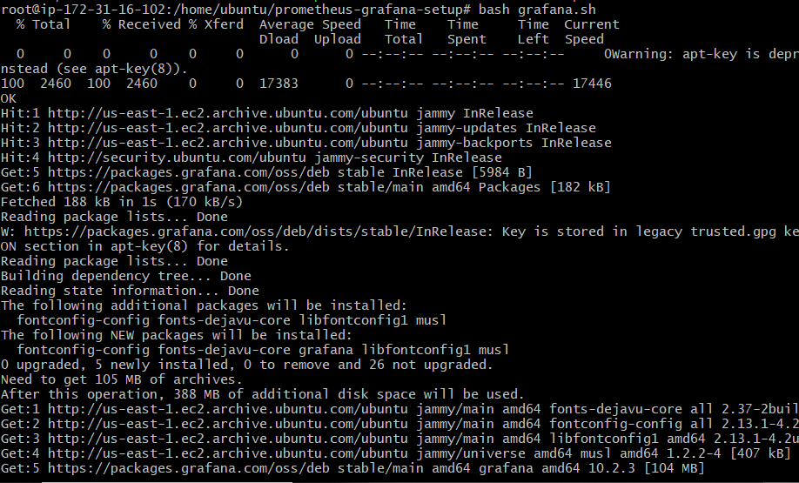

Allowed these ports to access Prometheus: 9090, Node_Exporter: 9100, Grafana: 3000

